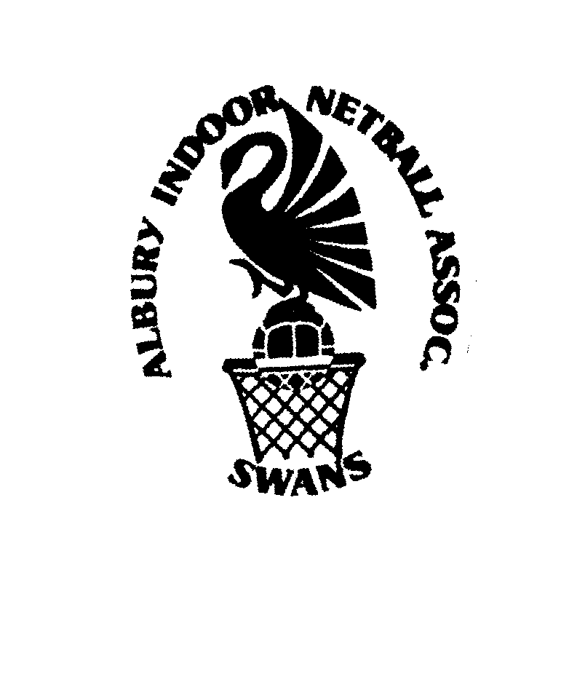
ALBURY INDOOR NETBALL ASSOCIATION INC
PO Box 531
Albury NSW 2640

Pl

6 November 2015

To whom it may concern

I am writing on behalf of the AINA Committee. We are a netball association located in rural NSW and once a year we hold a senior netball carnival where we have anywhere from 55 to 75 teams attend.
Five years ago I googled “netball gear” in an effort to try and find a company who might want to come to our carnival and set up their netball shop. 100% Netball were one of the companies I contacted and they got back in touch with me almost immediately.
From the very first moment we spoke, they have been nothing but professional and efficient, whilst still being friendly and ultra easy to get along with.
Glenn and Danny from 100% Netball have now been involved with five of our carnivals (and hopefully many more). They design our very own carnival T shirt, singlet top and hoodie which, by the end of the weekend, a high percentage of players are wearing. They are fantastic quality and look good too. They also have a comprehensive range of everything netball for players and umpires alike available to pre-order online and pick up at the carnival or to simply purchase during the carnival.
Glenn and Danny set up their shop the day before our carnival and then attend both days that our carnival is running. They do not begin to pack up until after the last final has been played. They are very reliable and honest which is very important to our association as they represent us.
100% Netball is a great company to work with – everything just happens seamlessly.
Feel free to ring or email me if you have any further queries.

Yours faithfully
Nanette Haberfield

NANETTE HABERFIELD

Treasurer / Registrar
Albury Indoor Netball Association Inc.
Mobile : 0412 489462
Email : nanette@davnette.com.au

